CSC205
Project 1: Assembly Language Programming in MARIE
Topic: Computing square

Total possible points: 0 (For practice purpose)

Write a program using the MARIE assembly language to evaluate the expression:
A * A
Your program should be able to perform the following:
- Read in A as an input entered by the user. Output your result to the screen. (Your program does not need to create any user prompt. Please figure out how to do the input/output in decimal values.)
- Handle all inputs that are positive integers. Test your program on Test set I.
- Handle all inputs that are non-positive integers. Test your program on Test sets II and III.
- Pass the automated IO test provided at https://github.com/huiannie/MarieTest

Test Set | Test number | Input | Correct output | Your output
I | 1 | 1 | 1
 | 2 | 4 | 16
 | 3 | 16 | 256
II | 4 | -3 | 9
 | 5 | -8 | 64
 | 6 | -15 | 225
III | 7 | 0 | 0

If your program is correctly implemented, its execution of the above tests may look like this:
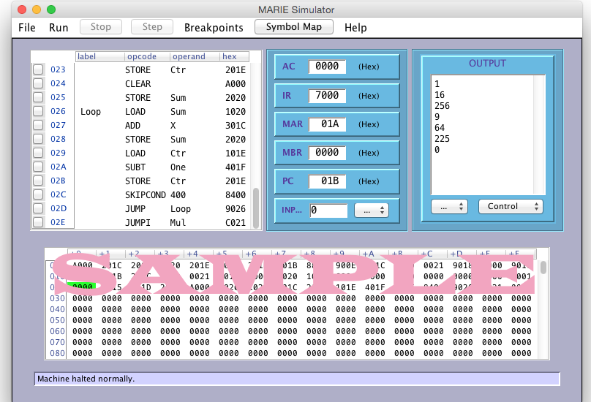

A correctly implemented program should be able to pass the automated IO test with results similar to this:

Start run 1  Testing input -20  Cleaned test output: 400  Expected output: 400  Test output seems correct  Run completed.  Start run 2  Testing input -19  Cleaned test output: 361  Expected output: 361  Test output seems correct  Run completed.  Start run 3  Testing input -18  Cleaned test output: 324  Expected output: 324  Test output seems correct  Run completed.  Start run 4  Testing input -17  Cleaned test output: 289  Expected output: 289  Test output seems correct  Run completed.  Start run 5  Testing input -16  Cleaned test output: 256  Expected output: 256  Test output seems correct  Run completed.  Start run 6  Testing input -15  Cleaned test output: 225  Expected output: 225  Test output seems correct  Run completed.  Start run 7  Testing input -14  Cleaned test output: 196  Expected output: 196  Test output seems correct  Run completed.  Test output seems correct  Run completed.  Start run 9  Testing input -12  Cleaned test output: 144  Expected output: 144  Test output seems correct  Run completed.  Start run 10  Testing input -11  Cleaned test output: 121  Expected output: 121  Test output seems correct  Run completed.  Start run 11  Testing input -10  Cleaned test output: 100  Expected output: 100  Test output seems correct  Run completed.  Start run 8  Testing input -13  Cleaned test output: 169  Expected output: 169 | Start run 12  Testing input -9  Cleaned test output: 81  Expected output: 81  Test output seems correct  Run completed.  Start run 13  Testing input -8  Cleaned test output: 64  Expected output: 64  Test output seems correct  Run completed.  Start run 14  Testing input -7  Cleaned test output: 49  Expected output: 49  Test output seems correct  Run completed.  Start run 15  Testing input -6  Cleaned test output: 36  Expected output: 36  Test output seems correct  Run completed.  Start run 16  Testing input -5  Cleaned test output: 25  Expected output: 25  Test output seems correct  Run completed.  Start run 17  Testing input -4  Cleaned test output: 16  Expected output: 16  Test output seems correct  Run completed.  Start run 18  Testing input -3  Cleaned test output: 9  Expected output: 9  Test output seems correct  Run completed.  Start run 19  Testing input -2  Cleaned test output: 4  Expected output: 4  Test output seems correct  Run completed.  Start run 20  Testing input -1  Cleaned test output: 1  Expected output: 1  Test output seems correct  Run completed.  Start run 21  Testing input 0  Cleaned test output: 0  Expected output: 0  Test output seems correct  Run completed.  Start run 22  Testing input 1  Cleaned test output: 1  Expected output: 1  Test output seems correct  Run completed. | Start run 23  Testing input 2  Cleaned test output: 4  Expected output: 4  Test output seems correct  Run completed.  Start run 24  Testing input 3  Cleaned test output: 9  Expected output: 9  Test output seems correct  Run completed.  Start run 25  Testing input 4  Cleaned test output: 16  Expected output: 16  Test output seems correct  Run completed.  Start run 26  Testing input 5  Cleaned test output: 25  Expected output: 25  Test output seems correct  Run completed.  Start run 27  Testing input 6  Cleaned test output: 36  Expected output: 36  Test output seems correct  Run completed.  Start run 28  Testing input 7  Cleaned test output: 49  Expected output: 49  Test output seems correct  Run completed.  Start run 29  Testing input 8  Cleaned test output: 64  Expected output: 64  Test output seems correct  Run completed.  Start run 30  Testing input 9  Cleaned test output: 81  Expected output: 81  Test output seems correct  Run completed.  Start run 31  Testing input 10  Cleaned test output: 100  Expected output: 100  Test output seems correct  Run completed.  Start run 32  Testing input 11  Cleaned test output: 121  Expected output: 121  Test output seems correct  Run completed.  Start run 33  Testing input 12  Cleaned test output: 144  Expected output: 144  Test output seems correct  Run completed. | Start run 34  Testing input 13  Cleaned test output: 169  Expected output: 169  Test output seems correct  Run completed.  Start run 35  Testing input 14  Cleaned test output: 196  Expected output: 196  Test output seems correct  Run completed.  Start run 36  Testing input 15  Cleaned test output: 225  Expected output: 225  Test output seems correct  Run completed.  Start run 37  Testing input 16  Cleaned test output: 256  Expected output: 256  Test output seems correct  Run completed.  Start run 38  Testing input 17  Cleaned test output: 289  Expected output: 289  Test output seems correct  Run completed.  Start run 39  Testing input 18  Cleaned test output: 324  Expected output: 324  Test output seems correct  Run completed.  Start run 40  Testing input 19  Cleaned test output: 361  Expected output: 361  Test output seems correct  Run completed.  Start run 41  Testing input 20  Cleaned test output: 400  Expected output: 400  Test output seems correct  Run completed.  Tests completed on file proj1a.mex  Summary: 41 of 41 runs correct.

